Template for NORDES 2015: Cut & Paste Your Paper Title here
Theme, first hand
(firstname lastname
AFFILIATION
name@name.EDU)
Theme, second hand
(FIRSTNAME LASTNAME
AFFILIATION
name@name.EDU)

abstract
In this conference publication template, the formatting requirements for submitting your paper to NORDES 2015 are described. All submissions to the conference must use this format. The easiest way to prepare your paper is simply to use this document, replacing the content with your own.
Every submission should begin with an abstract that fits the first column on the first page, like here. The abstract should be a concise statement of the problem, why it is a problem, your approach or idea, conclusions and contributions of the work to the field of design research.

Introduction
When creating your submission, you can use a standard word processing application and simply replace the content here with your own. This template contains special typeface styles (e.g. ‘NORDES Title’, ‘Contact info’, ‘Heading 1’, ‘Heading 2’, ‘Normal’, etc.), which you can use in order to format your own text properly and easily.
The paper title, author's names, affiliations, and email addresses run across the full width at the top of the first page, an example of a paper with two authors is given here. If affiliation or emails do not fit on one line, they can occupy multiple lines, as shown above, where a carriage return instead of a comma separates the institutional affiliation from the email.
Do not include other page numbers, headers or footers in your paper submission, than on this template.

THE LENGTH OF THE PAPER
There are five submission categories:
- Full paper submissions should have less than 6000 words, and must not exceed 10 pages including illustrations, figures, and references.
- Exploratory papers include design cases, position papers, work in progress, and emerging new research areas that may as yet lack solid theoretical foundations but point towards exciting new directions for design research. Exploratory papers should be a maximum of four pages including illustrations and references.
Exploratory papers can also be of a pictorial style and make extensive use of visuals in its arguing. Submissions should have less than 3000 words and must not exceed 10 pages including photos, figures, drawings and references.
- A workshop proposal should be a maximum of two pages and state its purpose, a tentative programme for the half a day.
- Exhibitions can present submissions of artefacts, installations and performances documented via pictures, videos or links to websites. A two-page paper explaining how the exhibition artefact relates to the conference’s overall theme of design ecologies should accompany each submission.
- Papers for doctoral consortium should have less than 2000 words. Applicants are encouraged to relate to the theme of the conference.

Anonymous For the review
The paper submitted for review must be anonymous. Leave out names of people, affiliations, references and other info that jeopardizes anonymity.
Instead of your name(s) you indicate what theme your submission should be assessed under. You could also name a second theme if you think that your contribution can fit into several themes.

COLOR, FIGURES, AND VIDEO
Color figures such as diagrams and images are encouraged – this is a design conference. When using color in diagrams, please remember that many people print papers in grayscale: do a test print.
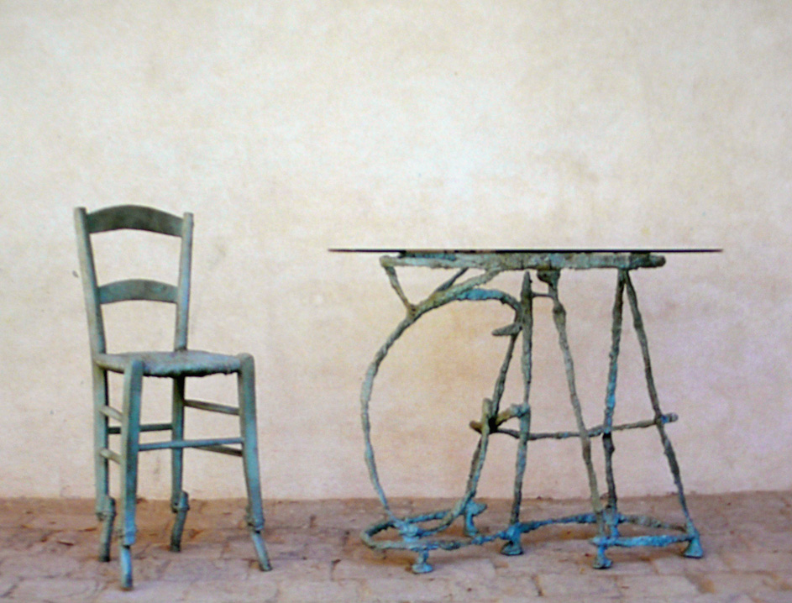
Figure 1: Text describing the sample image is encouraged. Captions are very accessible for readers.
Place figures as appropriate in relation to sections of the paper that refer to them, and they may be referenced in such text (see sample Figures 1 and 2). Figures may extend across one or both columns and should be labelled with captions underneath.
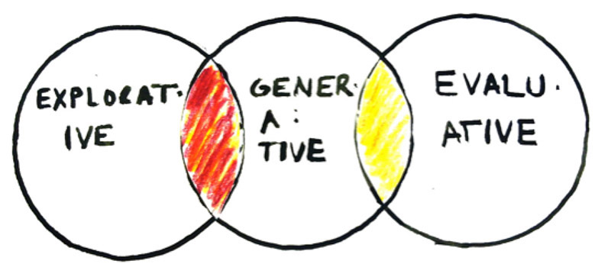
Figure 2: Example of a graph
Embedding short video clips into papers is possible, but remember that they do not print. Should you want to embed video into papers, contact us for instructions.
INFORMATION AND QUESTIONS
This template was adapted from the ACM conference format. Modification is inspired by the formats of the proceedings of the previous Nordes conferences.
If you have any questions concerning formatting or initial submissions, send your enquiry to kristina.lindstrom@mah.se or Asa.Stahl@mah.se.

Tables
Tables should be used where appropriate for the display of tabular information. Tables should be labelled with a caption in ‘Caption’ style above the table. Tables can be referred to in the following way (see Table 1). Tables should use the ‘Table text’ style for internal text. Please use bold text for table headings.
Table 1: NORDES 2015 conference highlights.
Day | Highlights
Sunday June 7th | Doctoral Consortium & Keynote
Monday 8th | Parallel Sessions & Design Evening
Tuesday 9th | Workshops & Conference Dinner
Wednesday 10th | Sessions, Keynote & Board Meeting

FORMATTING GUIDELINES
The paper should be formatted for A4 page size (21x29.7cm) with margins of 2cm on all sides. Columns should be of the same width, with a space between them measuring 0.8cm.
Spelling and punctuation may follow any consistent dialect of English (e.g., British, Canadian or American). Hyphenation is at your own discretion, but we suggest that only native English speakers with a Masters degree or more in English hyphenate – for the rest of us, hyphenating that language is time-consuming and prone to errors. We recommend writing in a straightforward style avoiding complex, colloquial, and gendered language, as well as explaining acronymns used and technical terms the first time they appear in the paper.
Please, use the full (extended) alphabetic character sets (for example, the letters ø, é, å, ç, â, ö, etc. in names of people, institutions and places as appropriate to the origin of the word). These characters are already included in the font used in this template and in most common typefaces.

Subsections
Paragraph and line spacing are applied automatically if you use the Microsoft Word styles to format your text.

font Instructions
The font used throughout the paper is Times New Roman Normal mixed case, unless specified otherwise.

Normal
- To be used for the main text throughout the paper.
- Size 10pt / Line spacing 12pt / 6pt after.

Caption
- To be used for captions beneath figures and transcripts.
- Size 8pt / Line spacing 9.6pt / 10pt after.

Table text
- To be used for internal table text
- Size 9pt.
- (Bold for table headings).

NORDES Title
- To be used for main title of the paper.
- Size 27pt / Line spacing 31pt.
- Upper-case.

Contact info
- To be used for author names, affiliations and email addresses.
- Size 10pt / line spacing 12pt.
- Upper-case.

Heading 1
- To be used for level 1 headings in the paper.
- Size 11pt / Line spacing 13.2pt / 11pt before / 2pt after.
- Upper-case.

Heading 2
- To be used for level 2 headings in the paper.
- Size 9pt/ Line spacing 12pt / 9pt before.
- Upper-case.

NORDES Abstract Header
- To be used for the heading of the abstract.
- Size 11pt / Line spacing 12pt / 11pt before / 8pt after.
- Upper-case.

NORDES Abstract Text
- To be used for the text of the abstract.
- Size 11pt / Line spacing 1.5 lines / 6pt after.

NORDES References
- To be used for references.
- Size 10pt / Line spacing 12pt / 6pt after
- Hanging paragraph indentation of 0.7 cm.

REFERENCing
References in text are done with author and year in brackets. Example:
...Rizzo claims that co-design is the future of business (Rizzo 2009). In broad terms, this may be true, but...
At the end of the document is a list of references in alphabetical order. References are written in the Harvard style. Links:
http://en.wikipedia.org/wiki/Wikipedia:Harvard_referencing
http://library.curtin.edu.au/referencing/harvard.pdf
http://www.fas.harvard.edu/~expos/sources/writing_with_sources.zip
References section is at the end of the paper:
Rizzo, F. 2009. Strategie di co-design. Teorie, metodi e strumenti per progettare con gli utenti. Milano: FrancoAngeli.
Bohrer, S., Zielke, T. and Freiburg, V. 1995, ‘Integrated obstacle detection framework for intelligent cruise control on motorways’, IEEE Intelligent Vehicles Symposium, Detroit, MI Piscataway, pp.276-281

Columns on the final pAge should be of equal length

