Template for ALL CONTRIBITIONS TO NORDES 2017: Cut & Paste Your Title here
Theme (select from list on website)
(first name last name
AFFILIATION
name@name.EDU)
Theme (select from list on website)
(FIRST NAME LAST NAME
AFFILIATION
name@name.EDU)

abstract
In this conference publication template, the formatting requirements for submitting Contribitions to NORDES 2017 are described. All submissions to the conference must use this format. The easiest way to prepare your Contribution is simply to use this document, replacing the content with your own.
Every submission should begin with an abstract that fits the first column on the first page, like here. The abstract should be a concise statement of the problem, why it is a problem, your approach or idea, conclusions and contributions of the work to the field of design research.

Introduction
When creating your submission, you can use a standard word processing application and simply replace the content here with your own. This template contains special typeface styles (e.g. ‘NORDES Title’, ‘Contact info’, ‘Heading 1’, ‘Heading 2’, ‘Normal’, etc.), which you can use in order to format your own text properly and easily.
The paper title, author's names, affiliations, and email addresses run across the full width at the top of the first page, an example of a paper with two authors is given here. If affiliation or emails do not fit on one line, they can occupy multiple lines, as shown above, where a carriage return instead of a comma separates the institutional affiliation from the email.
Do not include other page numbers, headers or footers in your paper submission, than on this template.

THE LENGTH OF THE CONTRIBITION
Please see the Contribution types on the conference website (www.nordes.org) and tailor this template accordingly for length and file size. This applies to any redirects to a ‘different track’.

CONFERENCE topic AND SUB THEMES
Please ensure that you address the conference theme directly as well as its key questions. Please re-read the call. In addition, do try to best identify thematics your contribitions covers. Ten of these are listed for your definition and intepretation as regards DESIGN+POWER.

Anonymous For the review
The final contribution should reintroduce all anonymised names and references.
The Contribition submitted for review must be anonymous. Leave out names of people, affiliations, references and other info that jeopardizes anonymity.
Instead of your name(s) you indicate what theme your submission should be assessed under. You could also name a second theme if you think that your contribution can fit into several themes.

COLOUR, FIGURES, AND VIDEO
Colour figures such as diagrams and images are encouraged – this is a design conference. When using color in diagrams, please remember that many people print papers in grayscale: do a test print.
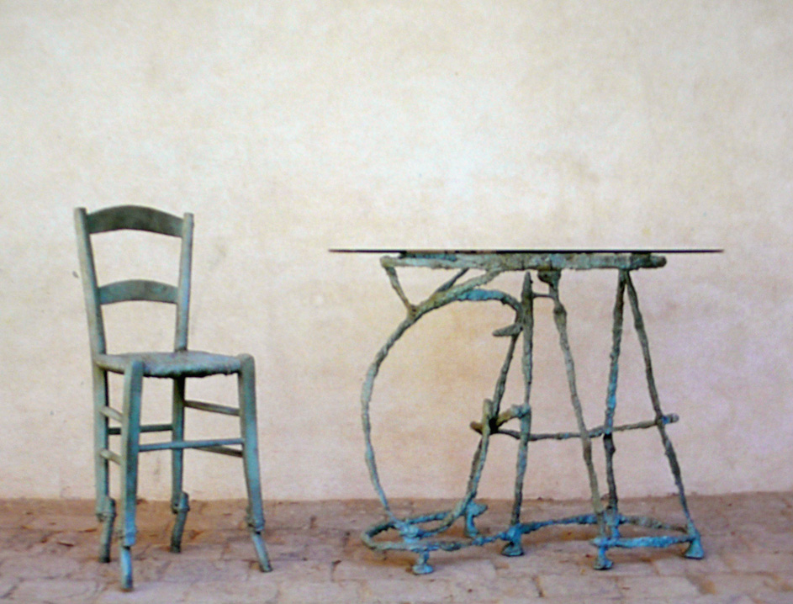
Figure 1: Text describing the sample image is encouraged. Captions are very accessible for readers.
Place figures as appropriate in relation to sections of the paper that refer to them, and they may be referenced in such text (see sample Figures 1 and 2). Figures may extend across one or both columns and should be labelled with captions underneath.
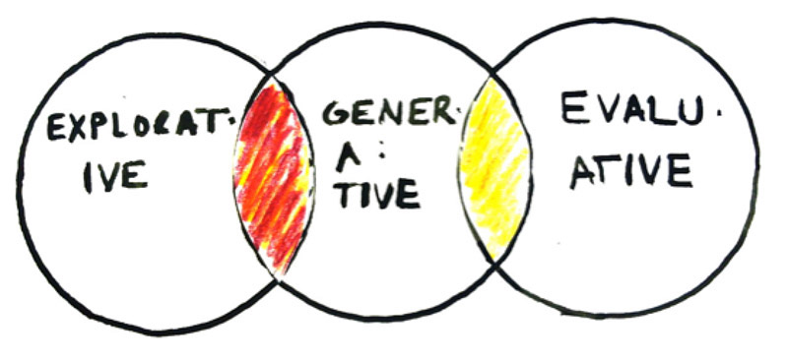
Figure 2: Example of a graph
Embedding short video clips into papers is possible, but remember that they do not print. Should you want to embed video into papers, contact us for instructions. We suggest a link to a secure and lasting site, such as Vimeo.
TEMPLATES AND QUESTIONS
If you have any questions concerning formatting or initial submissions, send your enquiry to andrew.morrison@aho.no

Tables
Tables should be used where appropriate for the display of tabular information. Tables should be labelled with a caption in ‘Caption’ style above the table. Tables can be referred to in the following way (see Table 1). Tables should use the ‘Table text’ style for internal text. Please use bold text for table headings.
Table 1: NORDES 2015 conference highlights.
Day | Highlights
Thursday 15th | Papers, keynotes, exhibition etc
Friday 16th | Parallel Sessions & Design Closing
Saturday 17th | Doctoral Consortium

FORMATTING GUIDELINES
The paper should be formatted for A4 page size (21x29.7cm) with margins of 2cm on all sides. Columns should be of the same width, with a space between them measuring 0.8cm.
Spelling and punctuation may follow any consistent variety of English (e.g., British, Canadian or American). Hyphenation is at your own discretion, but we suggest that only native English speakers with a Masters degree or more in English hyphenate – for the rest of us, hyphenating that language is time-consuming and prone to errors. We recommend writing in a straightforward style avoiding complex, colloquial, and gendered language, as well as explaining acronymns used and technical terms the first time they appear in the paper. Formal, specilaist and technical language should be used with precision, definitions and citations.
Please, use the full (extended) alphabetic character sets (for example, the letters ø, é, å, ç, â, ö, etc. in names of people, institutions and places as appropriate to the origin of the word). These characters are already included in the font used in this template and in most common typefaces.

Subsections
Paragraph and line spacing are applied automatically if you use the Microsoft Word styles to format your text.

font Instructions
The font used throughout the paper is Times New Roman Normal mixed case, unless specified otherwise.

Normal
- To be used for the main text throughout the paper.
- Size 10pt / Line spacing 12pt / 6pt after.

Caption
- To be used for captions beneath figures and transcripts.
- Size 8pt / Line spacing 9.6pt / 10pt after.

Table text
- To be used for internal table text
- Size 9pt.
- (Bold for table headings).

NORDES Title
- To be used for main title of the paper.
- Size 27pt / Line spacing 31pt.
- Upper-case.

Contact info
- To be used for author names, affiliations and email addresses.
- Size 10pt / line spacing 12pt.
- Upper-case.

Heading 1
- To be used for level 1 headings in the paper.
- Size 11pt / Line spacing 13.2pt / 11pt before / 2pt after.
- Upper-case.

Heading 2
- To be used for level 2 headings in the paper.
- Size 9pt/ Line spacing 12pt / 9pt before.
- Upper-case.

NORDES Abstract Header
- To be used for the heading of the abstract.
- Size 11pt / Line spacing 12pt / 11pt before / 8pt after.
- Upper-case.

NORDES Abstract Text
- To be used for the text of the abstract.
- Size 11pt / Line spacing 1.5 lines / 6pt after.

NORDES References
- To be used for references.
- Size 10pt / Line spacing 12pt / 6pt after
- Hanging paragraph indentation of 0.7 cm.

REFERENCing
For all submissions it’s a requirement for publication that you check your text thoroughly and revise all References.
References in text are noted with author and year in brackets. Example:
... Ståhl claims that co-design is the future of design inquiry (Ståhl 2016). In broad terms, her claims may be supportable, but ...
At the end of the document is a list of References is to be provided in alphabetical order (not using numbers as is done in e.g. Computer Science). References are written in the Harvard style. This is a requirement. References must be fully checked and contain FULL information, ie page numbers, volume and number of journals, etc.
Please follow the Harvard style. This is well documented. For example:
http://en.wikipedia.org/wiki/Wikipedia:Harvard_referencing
and
https://library.leeds.ac.uk/skills-referencing-harvard
and
http://education.exeter.ac.uk/dll/studyskills/harvard_referencing.htm

Columns on the final pAge should be of equal length

